1. Write a function to compute 5/0 and use try/except to catch the exceptions.

**Solution:**

Code:

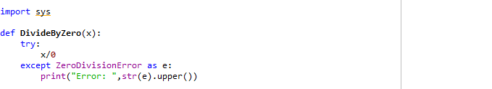

Input & Result



1. Implement a Python program to generate all sentences where subject is in ["Americans",

"Indians"] and verb is in ["Play", "watch"] and the object is in ["Baseball","cricket"].

**Solution:**

Code:

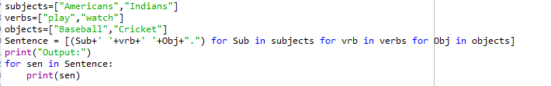

Input & Result

